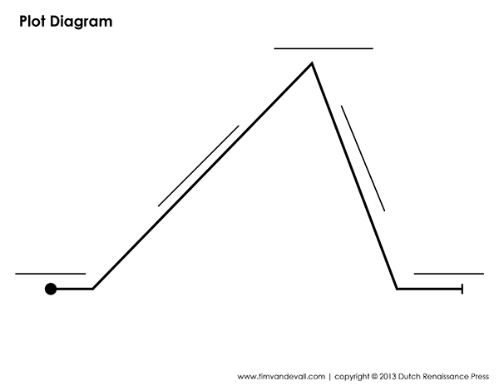Communications 11 Name:

**A Christmas Carol: Plot Diagram**