Socials 9 Name:
Historical Significance

Residential School Artifact Assignment

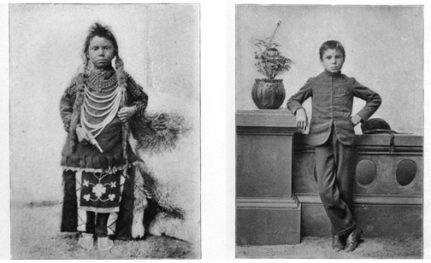
Learning outcomes:
- C3: I can explain the continuing effects of colonialism on Indigenous peoples in Canada
- CM5: I can share and present what I have learned
- CLT1: I can examine evidence from various perspectives
- CLT5: I can assess the significance of something and compare varying perspectives on their historical significance at particular times and places

Last class, we discussed what makes an event or object historically significant. You will now use your critical thinking skills to analyze an artifact that is related to Aboriginal experiences at Residential Schools.

- Step 1: Draw your artifact in the middle of your handout (don’t worry, I won’t grade you on your artistic skill!)
- Step 2: Use your “historical significance” handout and ask the questions in the right hand column about your artifact… e.g. does the artifact reflect some kind of change that a person/society went through?
- Step 3: Record your analysis or answers to the questions in the different boxes around your artifact
- Step 4: In the “Story ideas” box, write down some ideas about what kind of a story you could write that includes or is centered around the artifact you were given.
- Step 5: Write or create a written/visual story that includes your artifact
- Step 6: Practice presenting to a classmate (have them fill out criteria on the back)
- Step 7: Present to the class
  - We will display your artifact on the SmartBoard, and you will talk about what it is, and why it is significant (a summary of your analysis)
  - Also, share your story (or part of it) with us
  - See presentation criteria on the back

Social Studies 9 Name:
Giving Feedback

Artifact Oral Presentation: Peer Practice
Before you present your artifact to the class, you are required to practice with a partner, or a small group. You must have them fill out this peer assessment form and give you feedback about what you did well and what you can improve on.
Presenter: ______________________________________ Evaluator: _____________________________________________
Criteria: | Needs Improvement | Minimally Meeting | Good | Very Good
Content:
- Clear description of the artifact
- Explained the significance well: talked about changes, consequences, and different perspectives.

Spoke in complete sentences
Spoke clearly and confidently
Spoke at a good volume
Made eye contact with me
Used visual aids well (image of artifact)

2 things you did well:
- ________________________________________________________________________________________________________
- ________________________________________________________________________________________________________

1 thing you can improve:
________________________________________________________________________________________________________

