**Deep consequences over long period of time**

**Deep consequences (at the time)**

**Result in change**

**DRAW YOUR ARTIFACT**

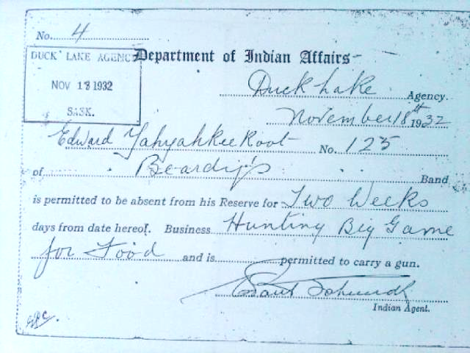

**Different perspectives of the artifact:**

**Change in perspectives (past vs. present)**

**Aboriginal person’s perspective:**

**Indian agent’s perspective:**

**Story ideas:**

**European/Government’s perspective:**