Black Death Station #1
Why is it called the Black Death?
Many think that the Black Death got its name from the blackened tumors that covered the victims' bodies. But it's more likely a mistranslation of the Latin term for the plague, Atra mors. "Atra" can be translated as either "terrible" or "black."
People living through the Black Death did not call it by that name. What they called it translates roughly to the "Great Mortality" or the "Big Death." People began using the phrase "Black Death" in the eighteenth century, to distinguish between the deaths of 1347-1351 and the plague that struck London in 1665.

#1.
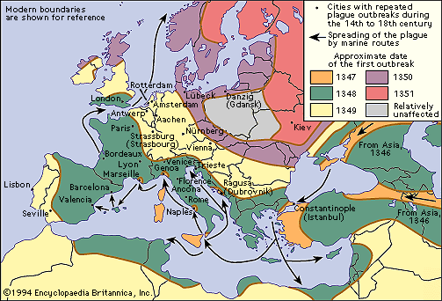

#2. From Boccaccio’s Decameron

Thirteen hundred and forty-eight [1348] years had passed since the fruitful Incarnation of the Son of God, when there came into the noble city of Florence, the most beautiful of all Italian cities, a deadly pestilence [disease], which, either because of the operations of the heavenly bodies, or because of the anger of God ordering punishment for our sinful ways, several years earlier had started in the Orient [the East/Asia], where it destroyed huge numbers of lives, barely resting in one place before it moved to the next, and turning westward its strength grew terribly.

#3.
Types of Plague:
Historians believe that there were several different plagues at this time:
Bubonic plague:
This was the most commonly seen form during the Black Death, with a mortality [death] rate of 30-75%. The germ is carried in the bloodstream by rats. Fleas which bite the rats become infected and then pass on the plague when they bite humans. These fleas multiply in the warm weather but die off in the winter. Of those who contracted the bubonic plague, 4 out of 5 died within 8 days.
Pneumonic plague:
Pneumonic plague was the second most commonly seen form during the Black Death, with a mortality rate of 90-95%. This plague is caught through breathing. It attacks the lungs. Patients cough blood and spray out germs when they breathe out. It kills people within 2 days.
Septicaemic Plague:
Septicaemic plague was the least common of the three forms, with a mortality rate close to 100%. When the bacteria multiply in the bloodstream, it is called septicemic plague. When untreated, both bubonic and pneumonic plague can lead to septicaemic plague.

#4. Video: “The past, present and future of the bubonic plague”
https://www.youtube.com/watch?v=ySClB6-OH-Q
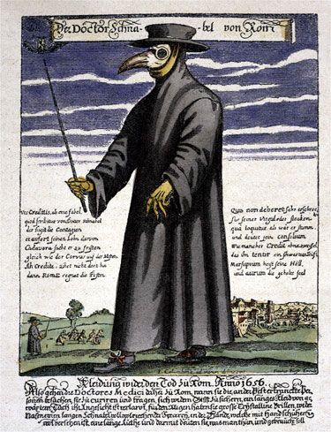
#5
Beak Doctor
A plague doctor would have worn a beak doctor costume in his role as a specialized doctor. He was known then as a “Beak Doctor”. The protective suit consisted of a heavy fabric overcoat that was waxed, a mask of glassed eye openings and a cone shaped like a beak to hold scented substances. Some of the scented materials were amber, balm-mint leaves, camphor, cloves, laudanum, myrrh, rose petals, and storax. A wooden cane pointer was used to help examine the patient without touching.
Historian O’Donnell says that a medieval plague doctor wore a long black oilcloth robe that had a hood. It was intended as a protection suit against the contagious plague. This costume had openings for the eyes that were made of glass. It also had a hollow long beak for the nose, which was filled with camphor, garlic, mint, or a sponge of vinegar. This was all to protect the doctor from miasmatic “bad air.”

Black Death Station #2

Scientists at the time did not know the real cause of the Black Death, some blamed ‘corrupt air’ or the movements of the planets for the outbreak. Some people even thought that the Black Death was a sign of God’s anger.

#1. Read your textbook page 166 “Persecution of the Jews” and the source below.
Primary Source: Jean de Venette on the Progress of the Black Death (France)
Some said that this pestilence [disease] was caused by infection of the air and waters, since there was at this time no famine nor lack of food supplies, but on the contrary great abundance. As a result of this theory of infected water and air as the source of the plague the Jews were suddenly and violently charged with infecting wells and water and corrupting the air. The whole world rose up against them cruelly on this account. In Germany and other parts of the world where Jews lived, they were massacred and slaughtered by Christians, and many thousands were burned everywhere, indiscriminately. For mothers hurled their children first into the fire that they might not be baptized and then leaped in after them to burn with their husbands and children. It is said that many bad Christians were found who in like manner put poison into wells. But in truth, such poisonings, [if they even happened], could not have caused so great a plague nor have infected so many people. There were other causes; for example, the will of God and the corrupt humors [see #2] and evil in air and earth. Perhaps the poisonings, if they actually took place in some localities, reinforced [added to] these causes.

#2.

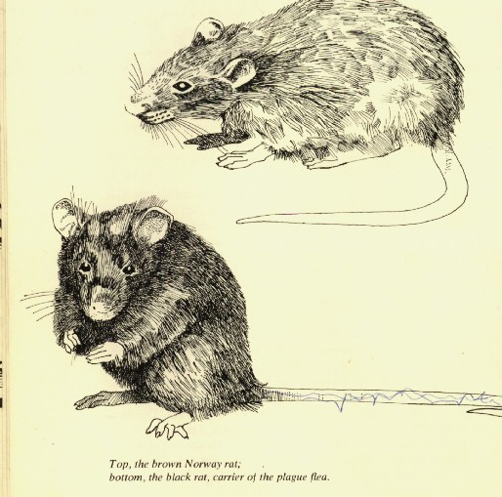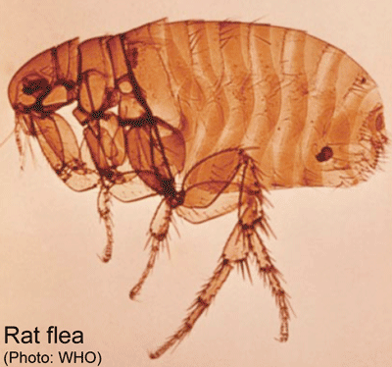
According to scientists today (unknown at the time), the plague is an infectious disease caused by the bacteria known as Yersinia pestis. Plague has a high fatality rate and has been described for centuries. Transmission occurs via fleas that feed on infected rodents. People contract the bacteria through bites of fleas that have fed on infected rodents. Humans can also develop the infection from handling fluids or tissues from infected animals. People with the pneumonic form of plague can transmit the infection to other humans by coughing infectious droplets into the air. Plague is still with us in many parts of the world, although now antibiotics can halt its course.
Some historians and scientists question these findings, because Yersinia pestis does not spread as easily or quickly today as it did at the time. It may be the same pathogen, but a different strain of the bacteria, which was more aggressive in the past.

#3.
Why did the plague spread so quickly?
The disposal of bodies was very crude and helped to spread the disease still further as those who handled the dead bodies did not protect themselves in any way.

Primary Source Excerpt: Boccacio’s Decameron
“Many others, who met their ends in their own houses, would first come to the attention of their neighbors because of the stench of their rotting corpses more than anything else; and with these and others all dying, there were corpses everywhere. And the neighbors always followed a particular routine, more out of fear of being corrupted by the corpse than out of charity for the deceased. These, either by themselves or with the help of others when available, would carry the corpse of the recently deceased from the house and leave it lying in the street outside where, especially in the morning, a countless number of corpses could be seen lying about. Funeral biers would come, and if there was a shortage of funeral biers, some other flat table or something or other would be used to place the corpses on. Nor did it infrequently happen that a single funeral bier would carry two or three people at the same time, but rather one frequently saw on a single bier a husband and a wife, two or three brothers, a father and a son, or some other relatives.”

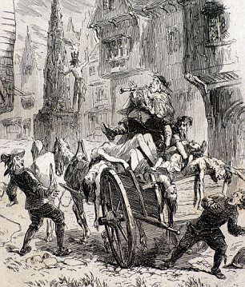
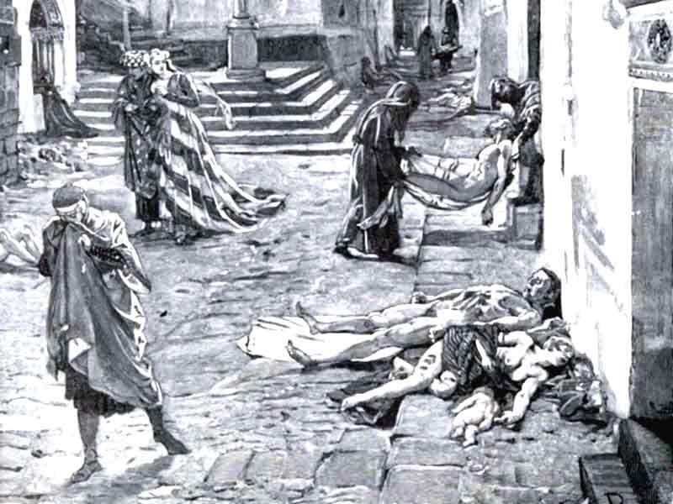

#4.
Primary Source Excerpt: Boccacio’s Decameron
Nor were there ever tears or candles or any company honoring the dead; things had reached such a point, that people cared no more for the death of other people than they did for the death of a goat: for this thing, death, which even the wise never accept with patience, even though it occur rarely and relatively unobtrusively, had appeared manifestly to even the smallest intellects, but the catastrophe was so unimaginably great that nobody really cared. There was such a multitude of corpses that arrived at all churches every day and every hour, that sacred burial ground ran out, which was especially a problem if each person wanted their own plot in accordance with ancient custom. When the cemeteries were for the most part full, they excavated great pits in which they'd place hundreds of newly arrived corpses, and each corpse would be covered with a thin layer of dirt until the pit was filled.

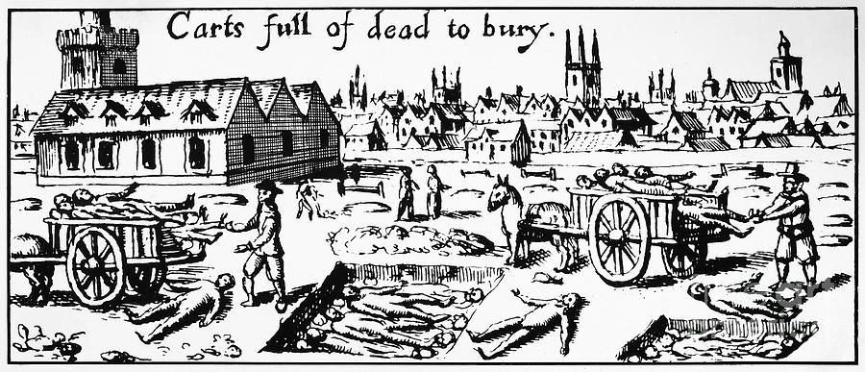
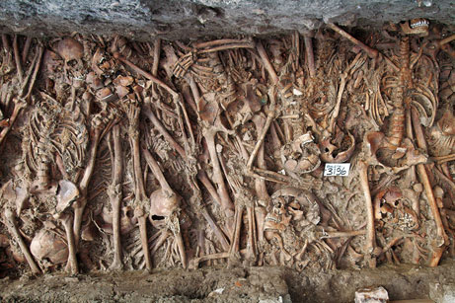
A mass grave for plague victims recently found in Italy
Station #3
Symptoms

#1.
Primary Source: from Boccaccio’s Decameron

“It began with swellings in the groin and armpit, in both men and women, some of which were as big as apples and some of which were shaped like eggs, some were small and others were large; the common people called these swellings gavoccioli. From these two parts of the body, the deadly gavaccioli would begin to spread and within a short while would appear over the entire body in various spots; the disease at this point began to take on the qualities of a deadly sickness, and the body would be covered with dark and livid spots, which would appear in great numbers on the arms, the thighs, and other parts of the body; some were large and widely spaced while some were small and bunched together. And just like the gavaciolli earlier, these were warnings of coming death.”

#2.
YouTube Video: “What Was the Black Death? What were the Symptoms?” https://www.youtube.com/watch?v=y7OWLohZ_fs

#3.

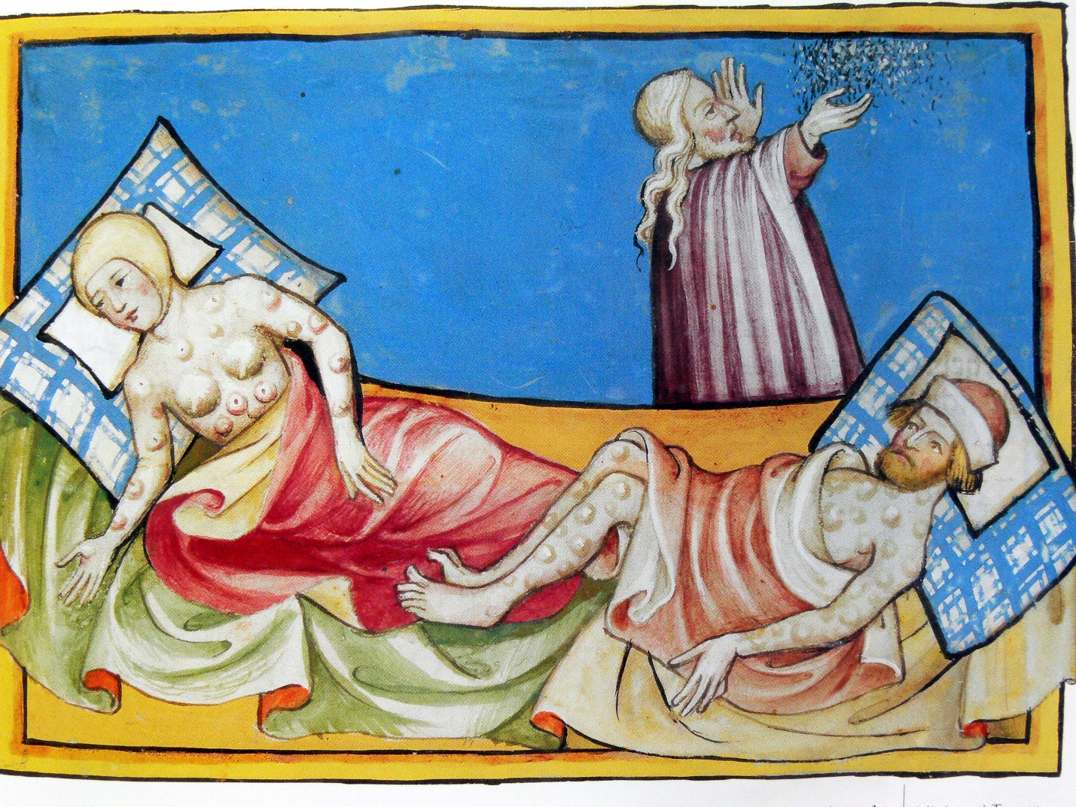

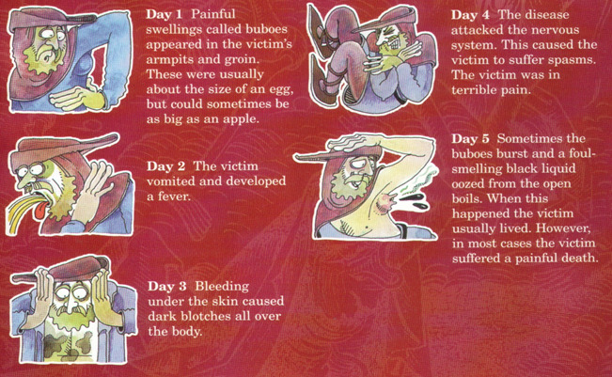
#4.

#5.
Primary Source: Jean de Venette on the Progress of the Black Death (France)

“In Paris and in the kingdom of France, and also in other parts of the world, [the spread of the Black Death] was so great that it was almost impossible to bury the dead. People lay ill little more than two or three days and died suddenly, as it were in full health. He who was well one day was dead the next and being carried to his grave. Swellings appeared suddenly in the armpit or in the groin -- in many cases both -- and they were always signs of death. This sickness or pestilence was called an epidemic by the doctors. Nothing like the great numbers who died in the years 1348 and 1349 has been heard of or seen of in times past. This plague and disease came from ymaginatione or association and contagion, for if a well man visited the sick he only rarely escaped the risk of death.”

Station #4
Responses
Prevention, Treatment, Reactions…

#1.
PREVENTION: Primary Source: from Boccaccio’s Decameron
“No human wisdom or foresight had any value: enormous amounts of refuse [garbage] and manure were removed from the city by appointed officials, the sick were barred from entering the city, and many instructions were given to preserve health; just as useless were the humble supplications [prayers] to God given not one time but many times in appointed processions, and all the other ways devout people called on God; despite all this, at the beginning of the spring of that year, that horrible plague began with its dolorous effects in a most awe-inspiring manner, as I will tell you.”

#2.
REACTION: Primary Source: from Boccaccio’s Decameron
“Diverse fears and imaginings were born in those left alive, and all of them took recourse to the most cruel precaution: to avoid and run away from the sick and their things; by doing this, each person believed they could preserve their health. Others were of the opinion that they should live moderately and guard against all excess; by this means they would avoid infection. Having withdrawn, living separate from everybody else, they settled down and locked themselves in, where no sick person or any other living person could come, they ate small amounts of food and drank the most delicate wines and avoided all luxury, refraining from speech with outsiders, refusing news of the dead or the sick or anything else, and amusing themselves with music or whatever else was pleasant.”
Others, who disagreed with this, believed that drinking beer, enjoying oneself, and going around singing and ruckus-raising and satisfying all one's appetites whenever possible and laughing at the whole bloody thing was the best medicine; and these people put into practice what they heartily advised to others: day and night, going from tavern to tavern, drinking without moderation or measure, and many times going from house to house drinking up a storm and only listening to and talking about pleasing things.”
“With so much sickness and misery, all respect for the laws, both of God and of man, fell apart and dissolved, because the ministers and executors of the laws were either dead or ill like everyone else, or were left with so few officials that they were unable to do their duties; as a result, everyone was free to do whatever they pleased.”
“[Some] people walked about freely, holding in their hands a posy of flowers, or fragrant herbs, or diverse exotic spices, which sometimes they pressed to their nostrils, believing it would comfort the brain with smells of that sort because the stink of corpses, sick bodies, and medicines polluted the air all about the city.”
Others held a more cruel opinion, one that in the end probably guaranteed their safety, saying that there was no better or more effective medicine against the disease than to run away from it; convinced by this argument, and caring for no-one but themselves, huge numbers of men and women abandoned their rightful city, their rightful homes, their relatives and their parents and their things, and sought out the countryside, as if the wrath of God would punish the evils/sins of men with this plague based on where they happened to be, as if the wrath of God was stirred against only those who unfortunately found themselves within the city walls, or as if the whole of the population of the city would be exterminated in its final hour.
“One citizen avoided another, everybody neglected their neighbors and rarely or never visited their parents and relatives unless from a distance; the ordeal had so withered the hearts of men and women that brother abandoned brother, and the uncle abandoned his nephew and the sister her brother and many times, wives abandoned their husbands, and, what is even more incredible and cruel, mothers and fathers abandoned their children and would refuse to visit them. As a result of that, a huge number of those, men and women, who fell ill, there remained no-one to care for them except for friends, which were very few, or greedy servants, who, despite the high salaries and easy service, became very rare.”

#3.

Cures for the Black Death
‘Cures’ for the Black Death went from the absurd to having a degree of common sense about them.
Vinegar and water treatment | If a person gets the disease, they must be put to bed. They should be washed with vinegar and rose water
Lancing the buboes | The swellings associated with the Black Death should be cut open to allow the disease to leave the body. A mixture of tree resin, roots of white lilies and dried human excrement should be applied to the places where the body has been cut open.
Bleeding | The disease must be in the blood. The veins leading to the heart should be cut open. This will allow the disease to leave the body. An ointment made of clay and violets should be applied to the place where the cuts have been made.
Diet | We should not eat food that goes off easily and smells badly such as meat, cheese and fish. Instead we should eat bread, fruit and vegetables
Sanitation | The streets should be cleaned of all human and animal waste. It should be taken by a cart to a field outside of the village and burnt. All bodies should be buried in deep pits outside of the village and their clothes should also be burnt.
Pestilence medicine | Roast the shells of newly laid eggs. Ground the roasted shells into a powder. Chop up the leaves and petals of marigold flowers. Put the egg shells and marigolds into a pot of good ale. Add treacle and warm over a fire. The patient should drink this mixture every morning and night.
Witchcraft | Place a live hen next to the swelling to draw out the pestilence from the body. To aid recovery you should drink a glass of your own urine twice a day.

#4.
Lack of medical knowledge meant that people tried anything to help them escape the disease. It was common belief at the time that the plague was due to God’s wrath, caused by the sins of mankind. Flagellants wanted to show their love of God by travelling from town to town whipping themselves, hoping that God would forgive them of their sins and that they would be spared the Black Death.
#5.
Flagellants at Doornik (Belgium) in 1349
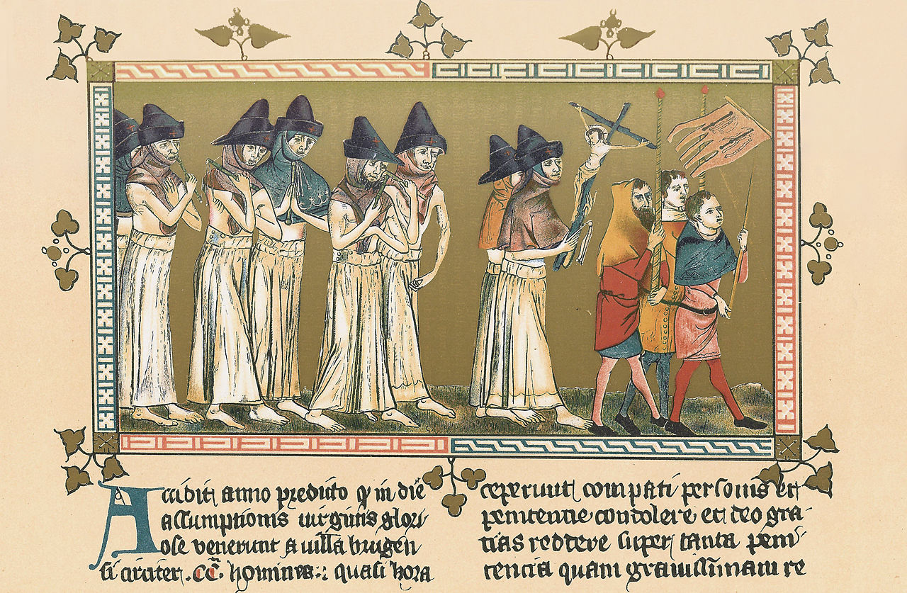

Black Death Station #5
The Impact
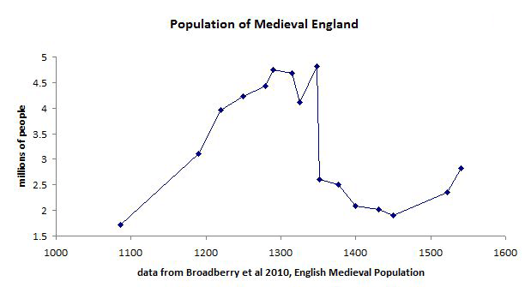
#1.

Some villages were deserted.
The Lord of the Manor could not get enough people to live and work on his land.
Food shortages (not enough workers!), some crops in fields were left to rot.
Price of food went up, in some parts of England they went up by 4 times!
Half the Clergy were wiped out.
Trade fell as prices of goods dropped.
A shortage of labour meant that workers wanted higher wages.
Many angry peasants ran away.
Some Lords refused to pay wages, making peasants work for nothing.

#2. Primary Source: Jean de Venette on the Progress of the Black Death (France)
The plague lasted in France for the greater part of the years 1348 and 1349 and then [stopped]. Many country villages and many houses in good towns remained empty and deserted. Many houses, including some splendid dwellings, very soon fell into ruins. Even in Paris several houses were thus ruined, though fewer here than elsewhere.
After this [end] of the epidemic, pestilence, or plague, the men and women who survived married each other. There was no sterility among the women, but on the contrary fertility beyond the ordinary. Pregnant women were seen on every side. . . . But woe is me! the world was not changed for the better but for the worse by this renewal of population. For men were more [greedy] and [selfish] than before, even though they had far greater possessions. They were more [jealous] and disturbed each other [more often] with [fights], disputes, and pleas. [Not] by the [death] resulting from this terrible plague [caused] by God was peace between kings and lords established. On the contrary, the enemies of the king of France and of the Church are stronger and wickeder than before and stirred up wars on sea and on land. Greater evils than before [swarmed] everywhere in the world. And this fact was very [surprising]. Although there were lots of goods, everything was twice as dear [more valued], whether it were utensils, [food], or merchandise, hired helpers or peasants and serfs.

#3. YouTube: “Impact of the Black Death” https://www.youtube.com/watch?v=OFMvDPRvL3M

#4. Effect on the Feudal System
Feudal law stated that peasants could only leave their village if they had their lord’s permission. Now many lords were short of desperately needed labour for the land that they owned. After the Black Death, lords actively encouraged peasants to leave the village where they lived to come to work for them. When peasants did this, the lord refused to return them to their original village.
Peasants could demand higher wages as they knew that a lord was desperate to get in his harvest.
So the government faced the prospect of peasants leaving their villages to find a better ‘deal’ from a lord thus upsetting the whole idea of the Feudal System which had been introduced to tie peasants to the land. Ironically, this movement by the peasants was encouraged by the lords who were meant to benefit from the Feudal System.

