- Define federation, confederation, and responsible government.
- Who recommended the idea of responsible government?
- Who did not like this idea? Why?
- Define mercantilism, corn laws, and depression. Explain how these terms affected the relationship the colonies had with the mother country, England.
- Fill in the chart using information from pages 73, 76-77
Factors in favour of Confederation | Factors against Confederation | Key people/terms

Building a nation
- Supported by: Canada West
- Not supported by: Canada East (didn’t want to be a minority in English speaking nation), maritime colonies (felt like they had little in common with the Canadas)
- Idea of a unified Canada stretching from sea to sea that would rival America
- Centralized government would control currency, defense, taxation, etc.
Towards Confederation
- 1846: British government repealed corn laws, which meant that there were no more special trading rights for Canada
- Canada’s economy went into a depression
- 1847: Britain named Lord Elgin governor of Canada; no longer britains responsibility
- Lord Durham: responsible government- entire gov’t responsible to the legislative assembly (elected by the people)
- 1849: government passed a bill giving money to anyone who had lost their property in the rebellions (including rebels)
- Lord Elgin was against bill but had to pass it (no vMeto due to responsible government)
- His signature laid the foundation for a new form of government for Canada- democracy
Advantages (generally) of confederation
- Stabilization of canada’s economy
- Tarrifs, trade barriers abolished
- Railway to link colonies for trade defence
- Prevent annexation by USA- idea of manifest destiny- make Canada appear bigger, stronger
- Worried about invasion after American civil war
https://www.youtube.com/watch?v=BDDmdzV3BzM
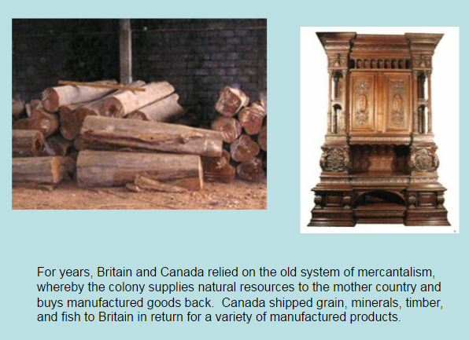
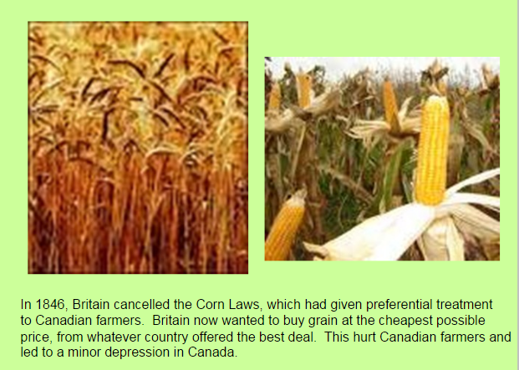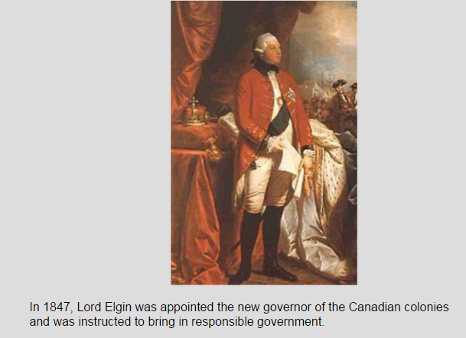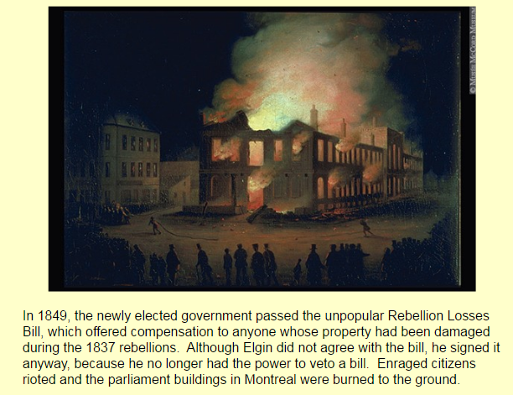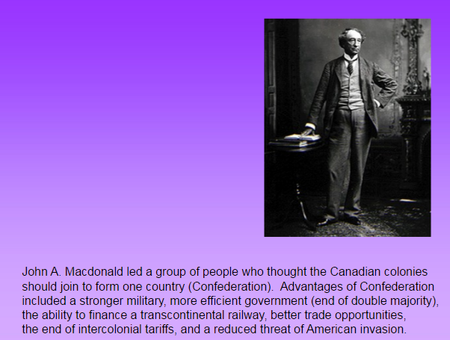We’We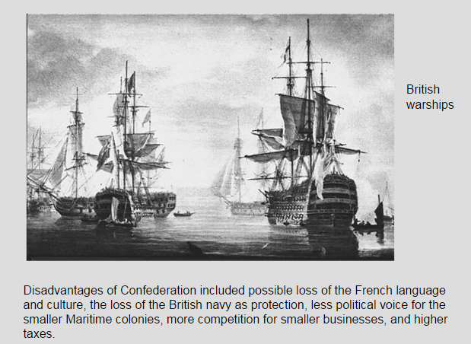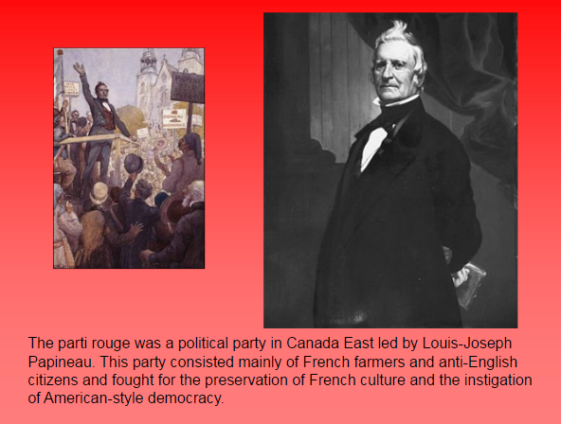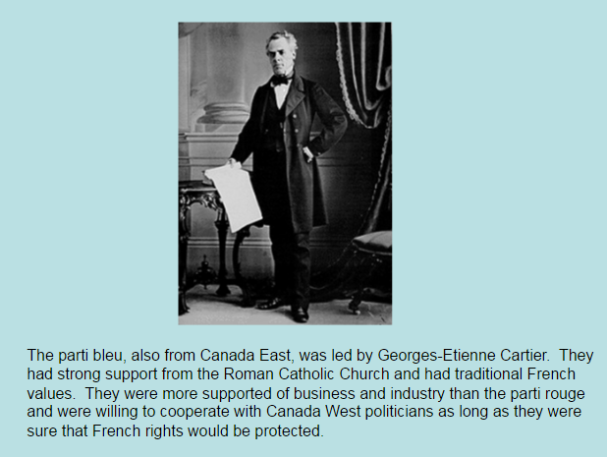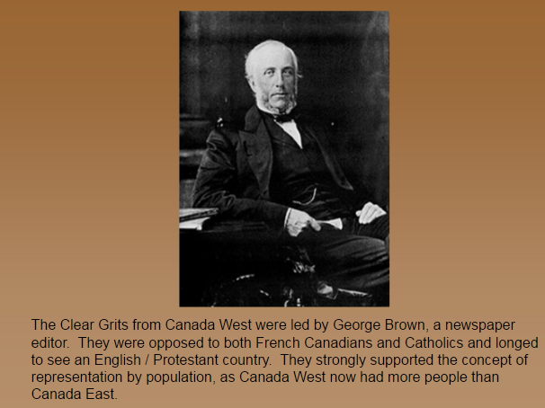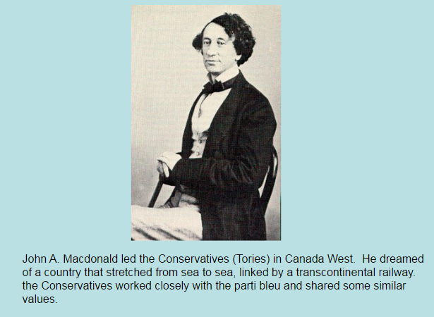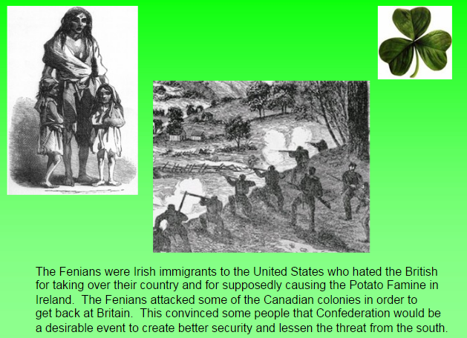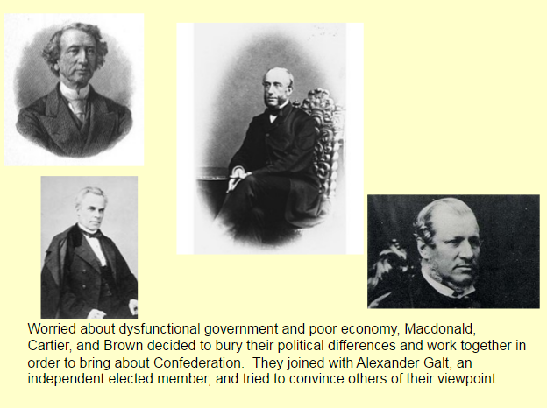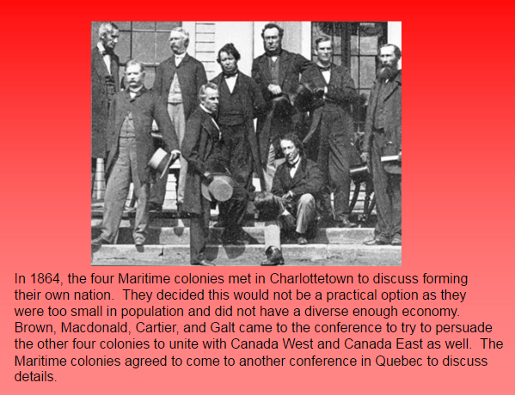
1. What is the Rebellion Losses Bill?
a. Why were people upset about it?
b. Why didn’t Lord Elgin sign it?
c. What response did the upset people have?
d. Why is this an important event for Canadian democracy?

2. International Treaties with the British colonies, 1840-1860s
a. Note: Be able to name the British colonies in North America at this time.
b. What were the Corn Laws?
c. Why did Britain repeal them in the 1850s?
d. How did this affect the British colonies in North America?
e. What was the trade treaty Britain had with the USA?
f. Why did the USA cancel this treaty in the 1860s?

3. Charlottetown Conference
a. What was the original purpose of this conference?
b. Who were the 3 leaders in the ‘Great Coalition’? What colony were they from?
c. What was the goal of the Great Coalition in attending the Charlottetown Conference?
d. What was the outcome of the Charlottetown Conference?

