Defending and Attacking a Medieval Castle
Attack
Blockading a Castle
- Though safer than fighting, starving occupants out of a castle was not always straightforward.
- Attacking armies, which often had hired mercenaries, were reluctant to wait out a winter in northern climates without permanent housing.
- Castle dwellers kept stockpiles of food and drilled water wells within the castle's walls.
- They also had ally troops that could come to their defence, sometimes turning a battle's tide.
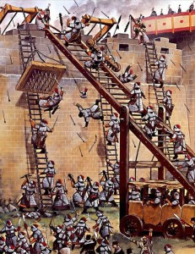
Direct Assault
- A direct assault was the most dangerous way for attackers to try to take a castle.
- Soldiers either scaled walls with ladders or overran castle walls breached by tunnels, battering rams, or artillery.
- Sometimes they attacked two or three spots around the castle at once to surprise their foe or divide castle defences.
- Defenders, perched on the castle wall had the upper hand.
- Archers rained arrows down on attackers, while soldiers pushed ladders off the wall with forked poles, dropped rocks or firepots onto the attackers.
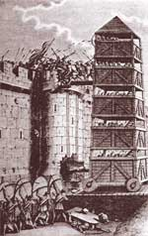

Siege Tower
- Attackers sometimes built a siege tower to scale castle walls.
- Soldiers lay in wait inside the structure as others wheeled it to the castle.
- Once there, the soldiers lowered a drawbridge at the top of the tower onto the castle wall.
- Some towers were almost 100 feet high, and in the siege of Kenilworth Castle, fully 200 archers and 11 catapults were crowded into a single tower.
- Siege towers were difficult and time-consuming to build.

Trebuchet
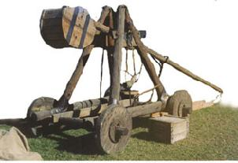
- During a siege, these missile launchers were one of the most fearsome weapons of medieval times.
- Powered by muscle, later a huge counterweight was used to make it swing.
- When the counterweight was dropped, a missile from a sling was launched.
- They could launch missiles hundreds of yards in large arcs at or over a wall.
- The best fired stone missiles weighing up to 400 pounds.
- Attackers also used them to launch dung or dead animals into the castle with the intention of spreading disease.
- Sometimes they even shot out the severed heads of enemy soldiers.
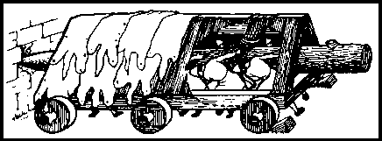

Battering Ram
- Siege armies used a battering ram to break down a gatehouse door or even smash a castle wall.
- To shield themselves from attack, they built a covered shed, in which they hung a thick tree trunk on chains suspended from a beam above.
- Carpenters tapered the trunk into a blunt point and capped it with iron.
- The slow forward movement as the battering ram was wheeled toward the castle wall earned it the nickname "tortoise."
- Soldiers swung the hanging trunk back and forth, and the forward end of the trunk moved in and out of the shed like a tortoise's head, battering its target.

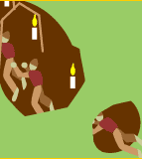
Tunnelling
- Men called sappers sometimes dug tunnels to gain entrance to a castle; launch a sneak attack.
- Usually these miners dug tunnels beneath a castle wall to destabilize and topple it.
- They supported their tunnels with timbers, which they then burned to collapse the tunnel and, hopefully, the wall above.
- To defend themselves, castle dwellers put out a bowl of water and watched for ripples that might indicate digging.
- Sometimes the castle's garrison built counter-tunnels; if the two tunnels met, fierce battles ensued underground

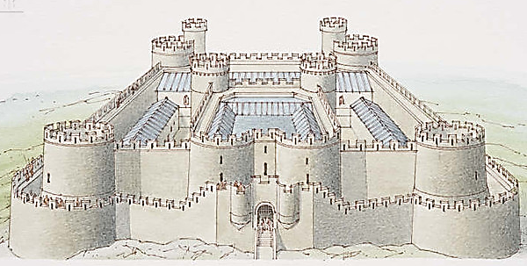
Defence
Walls
- From the mid-13th century, many castles had concentric rings of walls, one encircling the other.
- Low outer walls served as barriers against siege towers and battering rams. If attackers managed to break through this outer ring of defence, castle defenders could retreat behind high inner walls.
- Corner towers stood out from the walls, giving defenders a better perspective on enemy movements.
- Windows were rare; instead, slits called loopholes were built for archers.
- Sometimes builders thickened walls low to the ground to protect them from battering rams.
- Often, these walls sloped away at the base to redirect objects dropped from the top of the castle wall, ricocheting them out at soldiers on the ground.
Blockading
- Those inside made sure they could be self-sufficient when cut off from the outside world by a siege.
- They built wells and kept livestock inside their walls, guaranteeing fresh water and fresh meat during a siege.
- They also salted foods such as bacon and fish and stored grains and beans by the barrel-full.
- Castle garrisons also stockpiled weapons, for reinforcements often could not get through.
- If a siege continued into winter, castle dwellers had more protection from the elements than attackers, and if their rations held up, also more food to sustain them.
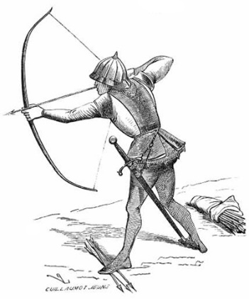
Archers
- Both attacking and defending armies had archers.
- Those shooting arrows from the castle had a great advantage as they launched arrows from a higher position. The castle wall also protected them well.
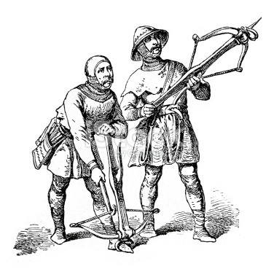
- Loopholes were often splayed to the inside, enabling archers to hide off to the side while reloading, giving them protection.
- The most powerful was the crossbow. Barbs on the head of a bolt, were often coated with beeswax to help them pierce armour.
- Crossbows took longer to load than the simple bow/longbow.
- Longbow archer could shoot ~ 12 arrows in the time it took to launch a single bolt.
- The longbow could send arrows as far as 1,000 feet.
- However, longbows took tremendous strength to shoot and much practice to control.

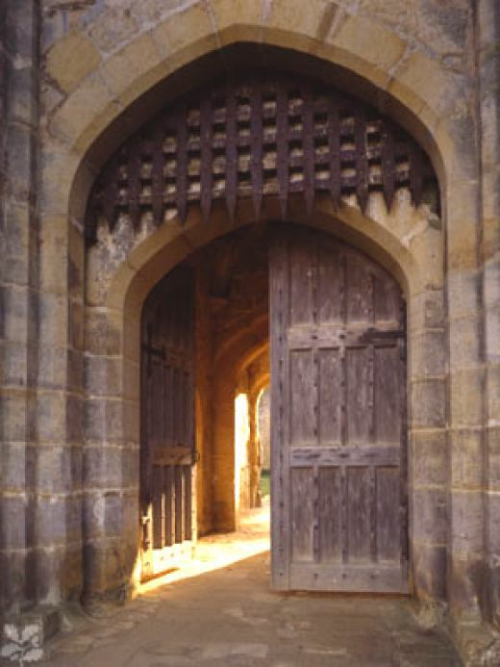
Gatehouse
- The gatehouse, the castle's entrance, was the early castle's most vulnerable point.
- Later, military engineers bolstered it with impressive defences.
- A drawbridge could be pulled back, lifted, or pivoted like a see saw.
- A portcullis—iron-covered wooden grills that moved up and down in front of the gatehouse door—provided additional protection.
- Castle dwellers could also slide wooden beams behind the doors to reinforce.
- If attackers entered the gate's passageway, they ran the risk of being trapped. By a second portcullis behind them.
- Roofs above gate passages often had "murder holes" through which castle soldiers could drop burning oil, hot sand, or scalding water.
- Loopholes in the gate passage gave archers deadly advantage.
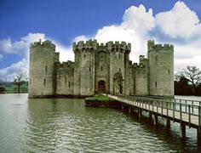
Moat
- Moats surrounding castles protected them from siege towers and battering rams.
- It also made digging tunnels underneath the wall far more challenging.
- To get across a moat, the attacking army sometimes filled the moat with rocks and soil or built portable wooden bridges.

