Social Studies 8 The Domesday Book Name: ___________________
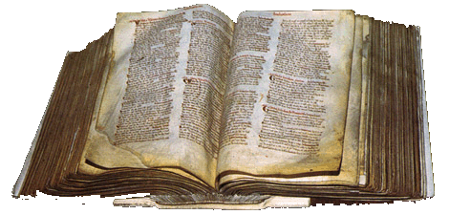
- What is the Domesday Book? ________________________________
________________________________________________________
- When was it made? _____________________
- What did it tell William the Conqueror? _________________________________________________________
Below is an excerpt from the Domesday Book. Read it, and answer the questions below.
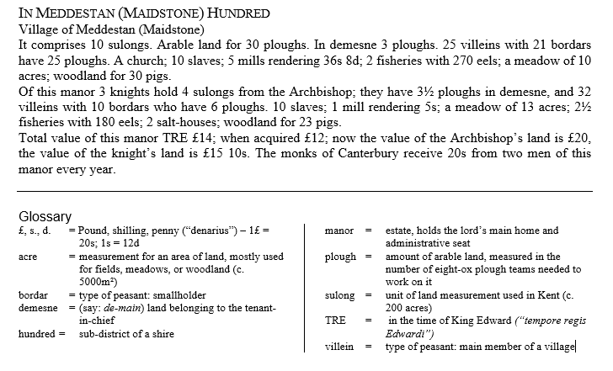

- What is a “plough”? ___________________________________________________________________________

- What are the different parts of the manor that are listed in this source? _________________________________ ___________________________________________________________________________________________

- What kind of animals do they raise on this manor? __________________________________________________

- What are the different types of people living on this manor? __________________________________________ ___________________________________________________________________________________________

