Social Studies
Earth Day: Political Cartoon Analysis Assignment

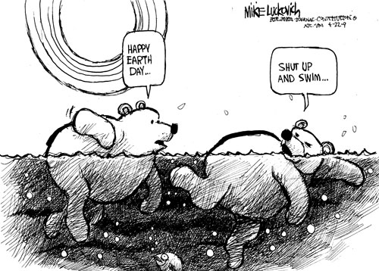
Critical Thinking:
- I can analyze and critique information
- I can explain different perspectives on present issues

Communication:
- I can share and present what I have learned

Instructions:
In pairs, or individually you will:
- Use the internet to find a political cartoon that relates to an environmental issue
- Save the image to Student Shared > Ms. Beck > Socials 9 > Environment Cartoon (save as your name(s))
- Complete the “Cartoon Analysis Sheet”
- Presentation
  - Next class, you will present your cartoon to the class orally. You can use the SmartBoard to display your image, and will explain to the class:
    - What the message of the cartoon is
    - The persuasive techniques that the artist uses
    - Whether you think it is persuasive
    - What could be done to make it better/more persuasive

