First Peoples & The Environment
Name:
Social Studies 9
Instructions: view and analyze the images of First Nations art on the PowerPoint. Answer the question below.
What can art tell us about Canada’s First Peoples?
___________________________________________________
___________________________________________________
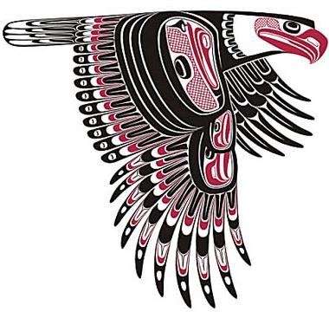
___________________________________________________
___________________________________________________

Instructions: read the handout about Traditional Ecological Knowledge. Summarize the main points below (point form).

Traditional Ecological Knowledge

- What is meant by SUBSISTENCE? ________________________________________________________________
___________________________________________________________________________________________

- Do we have a subsistence economy in our society? Explain why/why not. _______________________________
_________________________________________________________________________________________________________________________________________________________________________________________________________________________________________________________________________________
Questions
Instructions: answer the following questions in complete sentences. Make sure to be SPECIFIC and give examples and/or evidence to support your answers.
- How did Canada’s First Peoples interact with the environment? (Use some specific examples from your research and what we have learned; e.g. how did they use and depend on the land/resources, adapt to the land, etc.)
____________________________________________________________________________________________________________________________________________________________________________________________________________________________________________________________________________________________________________________________________________________________________________________________________________________________________________________________________________________________________________________________________________________________________________________________________________

- Is this different from how we interact with the environment in our society TODAY? Give some examples of the way that our society uses/adapts to the environment.
____________________________________________________________________________________________________________________________________________________________________________________________________________________________________________________________________________________________________________________________________________________________________________________________________________________________________

- Do you think we depend on our environment as much as the First Peoples did before contact? Explain why/why not.
____________________________________________________________________________________________________________________________________________________________________________________________________________________________________________________________________________________________________________________________________________________________________________________________________________________________________

- What do you think life would be like if all people treated the earth as the First Nations believe(d) it should be treated? Would things change? How?
________________________________________________________________________________________________________________________________________________________________________________________________________________________________________________________________________________________________________________________________________________________________________________________________________________________________________________________________________________________________________________________________________________________________________________________________________________________________________________________________________________________________________________________________________________________________________________________________________________________________________________________________________

