Social Studies 9: Exploration Unit Outline
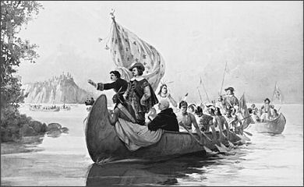
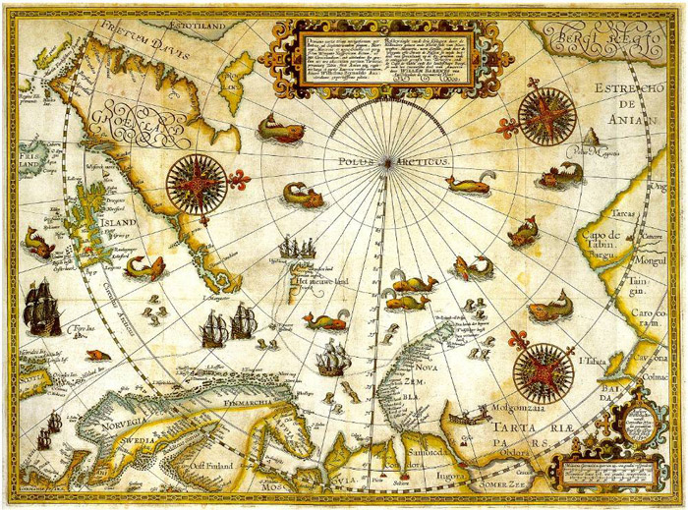

Content Learning Outcomes:
- I can define and give examples of imperialism, mercantilism, colonialism, and nationalism.

- I can explain why European explorers came to North America, and from where they came.

- I can describe what European explorers did when they came to North America, and how they treated/interacted with Indigenous peoples.

- I can explain the impact of European exploration on North America.

- I can compare and contrast exploration in the past with multinational companies that operate in the developing world today.

