Social Studies 10 Name:
Human & Physical Geography

Photo Analysis Project

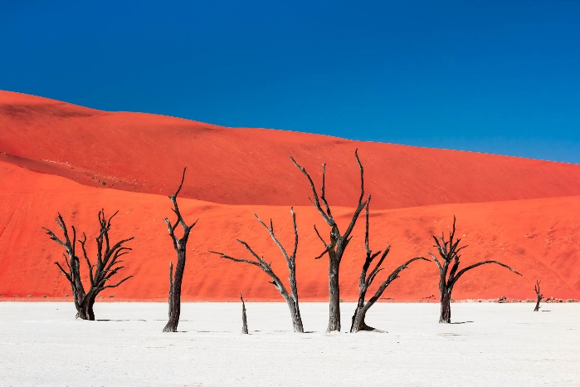
- Big Idea (#2): The physical environment influences the nature of political, social & economic change.
- Communication
  - 1: I can connect and engage with others by participating in discussions and group work.
  - 2: I can collaborate with others to plan and carry out activities
  - 3: I can acquire, interpret, and present information
- Critical thinking: (Students fill in this section)

Instructions: Students will be divided into pairs to select TWO photographs for group analysis (ONE related to Physical Geography and ONE related to Human Geography) using the same format as our photo analysis class. Students will be required to separate the Photo from the caption on two different Powerpoint/Prezi slides [saved into Student Shared drive: Ms. Beck>Socials10>Photo Analysis]. Each group will solicit guesses from the class regarding location & context. Each group will then debrief the photo by addressing the following:
- Describe the location of the photo (WHERE?)
  - Absolute location
    - GPS coordinates
  - Relative location
    - Map with country, region, etc.
    - Features of the area, if applicable

- Explain the context of the photo
    - Who (photographer & subject)
    - What
    - When
    - Why

- Explain the connection to Geography (Human, physical, etc.)

See example provided in class, or on class website.
Resources:
https://www.flickr.com/photos/flickr/galleries
http://www.creativebloq.com/photography/instagram-2131996
http://photography.nationalgeographic.com/photography/

Evaluation Criteria: (Co-created with class)

