**How important was the Church in the 12th century?**

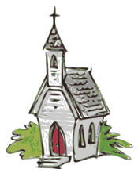These statements will help you to explore how important the Church was in people’s lives.

Read each statement and decide how powerful you think it makes the Church sound. Put a mark on the line to show this.

Not important at all

A bit important

Extremely important

**A.** Everyone believed in heaven and hell. They knew they had to obey the teachings of the Church to get to heaven.

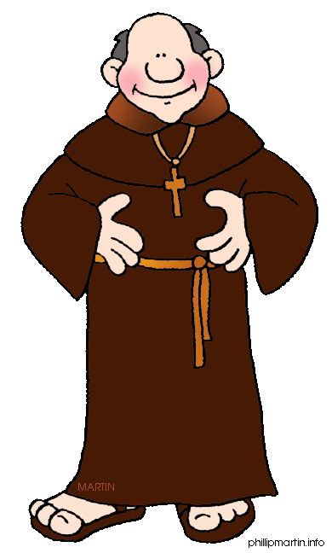

Not important at all

A bit important

Extremely important

**B.** Priests and monks were treated differently to ordinary people if they got  
 in trouble. They were tried in Church courts and more likely to be let off.

Not important at all

A bit important

Extremely important

**C.** Churches (even ones in villages) were very big, expensive and awesome!

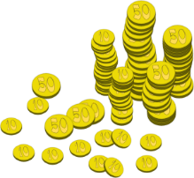

Not important at all

A bit important

Extremely important

**D.** People paid a tax (called a tithe) to the Church as well as to the King. This paid for new churches and monasteries to be built.

Not important at all

A bit important

Extremely important

**E.** The Archbishop of Canterbury was in charge of the Church in England.

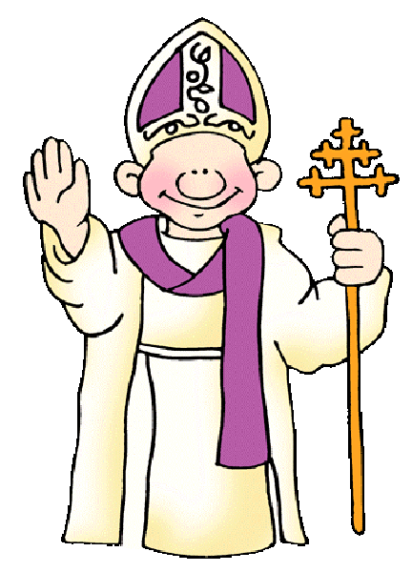

Not important at all

A bit important

Extremely important

**F.** The Pope was in charge of the whole Christian Church.

Not important at all

A bit important

Extremely important

**G.** The Archbishop of Canterbury was chosen by the King, but the Pope had to approve.

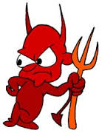

Not important at all

A bit important

Extremely important

**H.** The Archbishop had the power to excommunicate people – cut   
them off from all religion and damn them to hell!

**TASK:** Write a paragraph answering this question:

***How important*** *was the church in Medieval Europe?*