Communications 11 Name:
Convicts’ Letters of Advice to Past Selves

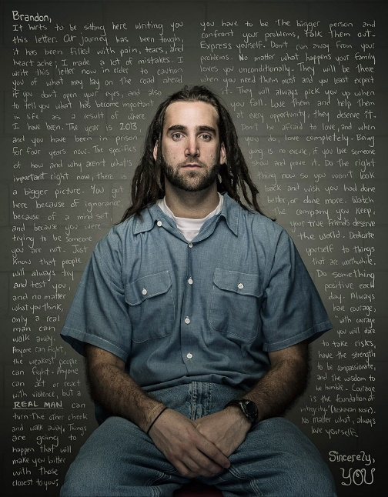
Commercial photographer Trent Bell has created a series of powerful images that shows us what a group of U.S. Convicts would tell their past selves if they could turn back the hands of time. In the “Reflect” project, each inmate was first asked to pen a letter to their past selves. Bell then took their portraits and had the text of their letters edited into the images, serving as powerful testaments to their regrets, their mistakes, and their new-found wisdom.
The idea arose in early 2013, when something unthinkable happened – his friend, an educated professional, husband and father of four, was sentenced to 36 years in prison. Bell was struck not only by his friend’s bad decisions and loss of freedom, but also by his new-found understanding of just how easily everything can go wrong.
His series is perhaps most striking for its emotional and moral value; “Our bad choices can contain untold loss, remorse, and regret,” the photographer explains on his website, “but the positive value of these bad choices might be immeasurable if we can face them, admit to them, learn from them and find the strength to share.”
Video link” https://vimeo.com/87289244
Reading Comprehension
Instructions: View and read the provided letters and portraits, and answer the following questions.
Write down 5 of the inmates’ bad choices/regrets that they reflect on in their letters. (5 marks)

Choose 5 pieces of good advice that the inmates give to their younger selves. (5 marks)

Writing Assignment: A Letter to Yourself
You may not have as much life experience as the men that participated in this project, but it is still valuable for you to reflect on your past, the present, and what you want your future to be.
For this assignment, you will write a letter to either
- Your younger self
- Yourself now
- Your future self
The content of your letter should be similar to the inmates’ letters: it should focus on life lessons, values, advice, and hopes or dreams. Whether you choose to write to your younger self, present self, or future self, you should include some self-reflection about your life, choices, and future. I will be the only person reading these, so feel free to be candid and honest with yourself.
Criteria:
Your letter should be:
- At least one page long, single spaced.
- Written in complete sentences
- Written using the proper letter format (see example attached)
- Folded and place it in an addressed envelope (see example below). You can make up an address if you do not want to use your own.

Ideas:
What are some of the bad/choices or regrets the inmates had that you have made, are making, or see yourself making in the future?

What are some pieces of advice they give that your younger/present/future self need to hear?

Address envelope
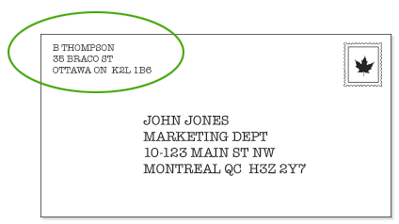

Letter Format

Return Address Line 1
Return Address Line 2
Date (Month Day, Year)
Dear (Name of Recipient),
Body Paragraph 1 . . . . . . . . . . . . . . . . . . . . . . . . . . . . . . . . . . . . . . . . . . . . . . . . . . . . . . . . . . . . . . . . . . . . . . . . . . . . . . . . . . . . . . . . . . . . . . . . . . . . . . . . . . . . . . . . . . . . . . . . . . . . . . . . . . . . . . . . . . . . . . . . . . . . . . . .
Body Paragraph 2 . . . . . . . . . . . . . . . . . . . . . . . . . . . . . . . . . . . . . . . . . . . . . . . . . . . . . . . . . . . . . . . . . . . . . . . . . . . . . . . . . . . . . . . . . . . . . . . . . . . . . . . . . . . . . . . . . . . . . . . . . . . . . . . . . . . . . . . . . . . . . . . . . . . . . . . .
Body Paragraph 3 . . . . . . . . . . . . . . . . . . . . . . . . . . . . . . . . . . . . . . . . . . . . . . . . . . . . . . . . . . . . . . . . . . . . . . . . . . . . . . . . . . . . . . . . . . . . . . . . . . . . . . . . . . . . . . . . . . . . . . . . . . . . . . . . . . . . . . . . . . . . . . . . . . . . . . . .
Closing (Sincerely...),
Signature
P.S.

