Social Studies 9 Name:
The Role of Mercantilism in Colonialism
Read the section in the green box on pg. 237 of your Crossroads textbook.
- Explain what the theory of mercantilism is.

- How can countries make large profits?

- What was the purpose of the colony?

- Fill in the missing information for the following diagram:

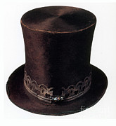
COLONY HOME COUNTRY
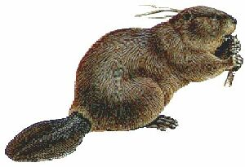
FRANCE & other countries (market for goods)

Other Colonies = markets for the surplus (left over) goods

Home country =

___________________________

Result = ___________________________

Restrictions = ___________________________
Colony = source of

___________________________

Result = ___________________________

Restrictions = ___________________________

- Which group of people do you think benefitted most from mercantilism?

- Can you think of a similar thing that is happening in our world today? (Think about how/where our goods are produced… where the raw materials come from…)

