Social Studies Name:
Miss Representation & the Mask You Live In
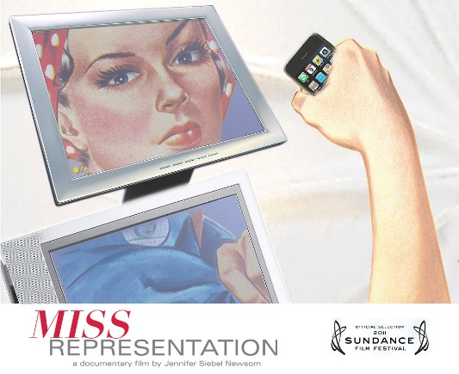
Pre-Viewing Questions
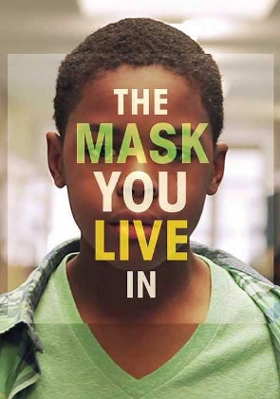
The media is any form of mass communication, and includes things like TV, internet, apps, video games, movies, etc.
- Which types of media do you use most often?

- About how many hours out of each day do you spend connected to the media in some way?

- How are women represented in the media? (Characteristics, roles they play, actions, etc.)

- How are men represented in the media? (Characteristics, roles they play, actions, etc.)

- What kind of pressures do you feel from your peers, the media, etc. to be, look, or act a certain way based on your gender?

While Viewing: Miss Representation
Things that stood out to me: (notes that will help you remember the documentary)

Questions I have
(Something you’d like to ask anyone in the film/question you have about the content/something that confused you, etc.)

Connections
(To your life/experiences, to a movie/tv show you’ve seen, or a book/article you’ve read)

After Viewing Questions for Miss Representation
Instructions: Answer the following questions in complete sentences. Make sure to back your opinion or viewpoint with evidence from the documentary or your own life experiences.
- Do you think that this documentary was accurate about the issues it discussed and portrayed? Explain.

- How much do you think we absorb societal views about women’s bodies? Explain.

- Is there a double standard for men’s and women’s bodies? Explain why you think there is/is not.

- Do you think things are getting better for women? Staying the same? Getting worse? Why? (give evidence from your experiences, etc.)

- Why do you think that women in power are seen so negatively?

- Who do you consider to be the strong female role models of today?

- Do you believe the media is as powerful as this documentary makes it out to be in terms of shaping our lives and our society?

While Viewing: The Mask You Live In
Things that stood out to me: (notes that will help you remember the documentary)

Questions I have: (something you’d like to ask anyone in the film/question you have about the content/something that confused you, etc.)

Connections
(To your life/experiences, to a movie/tv show you’ve seen, or a book/article you’ve read)

After Viewing Questions for The Mask You Live In
Instructions: Answer the following questions in complete sentences. Make sure to back your opinion or viewpoint with evidence from the documentary or your own life experiences.
- What is meant by “the mask you live in”?

- Based on the documentary and/or your own experience, do you agree that boys are made to wear a mask? Why/why not? How is it the same or different for girls?

- Do you think that hyper-masculinity harms boys? Why and how?

- What does the saying “boys will be boys” mean to you? Are there any problems with this saying?

- What challenges do you think men and boys silently face? Are these the same/different challenges for women and girls? Explain.

- Do you think women’s expectations of men have been affected by the way our culture perceives and defines masculinity? Explain.

- Do you think media stereotypes are worse for men or women?

- What could we do as individuals to change perceptions and stereotypes about men and women?

