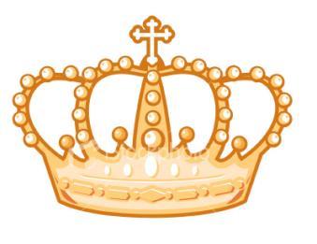

***Instructions:*** Using information from the PowerPoint/your textbook, label the pyramid, and write at least two important things about each layer.

Third Estate

Second Estate

First Estate