Social Studies 8 Name: ____________________
Medieval Religion
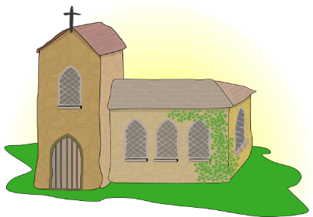
What can the images of churches tell us about religion in the Middle Ages?

- Fill in the blanks:
In the middle ages, the only religion was the __________________ religion. Everybody went to _________________. The services were in ____________ but there were _______________ and ________________ to help ordinary people understand. People believed that by going to church, they would get to _______________________. People left money to the church so that when they died the priest would say prayers for their soul so that they would not go to _______________________, the place between heaven and hell.
Latin Purgatory Catholic Paintings Heaven Statues Church
- How was the church structured?

- _____________________________ Duties:
- _____________________________ Duties:
- _____________________________ Duties:
- _____________________________ Duties:

- A tithe was:

Doom Paintings
Answer the following questions in FULL SENTENCES.
- What were doom paintings?

- Why do you think the church created them?

- Using the paintings you looked at, use 5 words to describe what hell seemed like.

- In what ways are the people being punished?

- Do you think that seeing these paintings in church would make people afraid of going to hell? Why/why not?

- Would you be tempted to pay the church to take your sins away?

Routes to Heaven
Walk around the room to view the information on the 4 different routes to heaven.
Record at least 3 pieces of information about each route.

Route 1
Route 2
Route 3
Route 4

- Which route(s) would you recommend to:

  - A peasant and his wife, poor hardworking peasants.
  - A rich merchant who travels around a lot.
  - The wife of a nobleman who died in the Crusades.
  - A tradesmen and his wife. Whilst not rich they have a little money to spare.

