Social Studies 10
Course Outline and Class Expectations

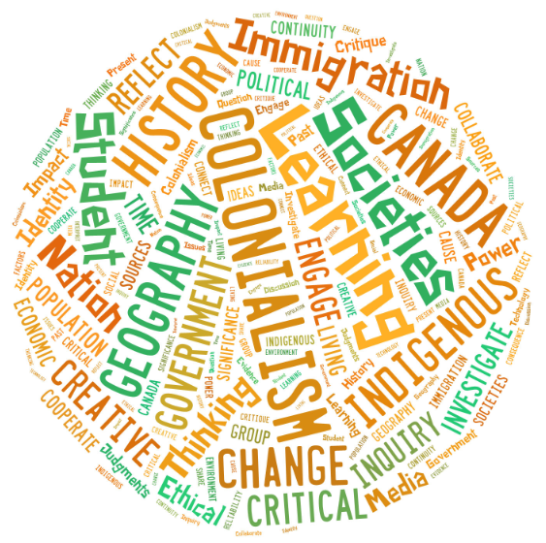

Ms. Beck
Room 216
jbeck@sd91.bc.ca
Website: missbecksclass.weebly.com

Textbook: Horizons: Canada Moves West

Course Overview

Welcome to Social Studies 10! Social Studies is designed to help you critically reflect upon events and issues in order to examine the present, make connections with the past, and consider the future. The aim of Social Studies is to help you become an educated citizen, which means being a thoughtful citizen who is able to acquire information, consider multiple perspectives, and make learned opinions and judgments. Throughout the course, students will be exposed to many different ideas and perspectives.

Key Areas of Focus

This course is based on the structure and philosophy of the New B.C. Curriculum. We will be examining several Big Ideas, linked to content knowledge, with the goal of improving the key skills that will help you succeed in life.
Each student will receive a copy of the learning outcomes for this course (also posted on class website), and will assess their progress throughout the course. They will also create and present an ePortfolio which will showcase artifacts as evidence of their learning and skill development.

BIG IDEAS
(what you will understand by the end of this course)

- Collective identity is constructed and can change over time
- Disparities in power alter the balance of relationships between individuals and between societies
- Emerging ideas and ideologies profoundly influence societies and events
- The physical environment influences the nature of political, social, and economic change

Content Knowledge
(the events/issues we will explore in class)

    - Political, social, economic, and technological revolutions
    - The continuing effects of imperialism and colonialism on Indigenous peoples
    - Immigration and population growth
    - The development of Canada as a nation
    - Local and regional conflicts
    - Discriminatory policies, attitudes and historical wrongs
    - Physiographic features of Canada and geological processes
Communication Skills  - Connecting and engaging with others through discussion and group work  - Reflecting on your learning  - Sharing and presenting what you have learned  - Giving and receiving feedback | Critical Thinking Skills  - Examining evidence  - Assessing reliability of sources  - Questioning, investigating, analyzing  - Assessing the significance of peoples, places and events  - Explaining change and identifying key turning points in history  - Identifying and assessing cause and consequence  - Exploring and explaining different perspectives
Creative Thinking Skills  - Generating new ideas to solve problems or address issues  - Developing creative pieces of work  - Making ideas work within given constraints | Positive Personal and Cultural Identity  - Identifying how your life experiences contribute to your identity  - Describing your personal values  - Taking ownership of your learning, and behaviour  - Identifying your strengths and abilities  - Considering others’ views  - Initiating positive change  - Analyzing complex issues from multiple perspectives  - Making reasoned ethical judgments

Materials

- A binder for handouts and in-class assignments
- Lined paper
- Pencil/pen
- Horizons textbook

Please come to each class prepared with all of your materials

Evaluation

A student’s evaluation is ongoing and cumulative; there is no Term 1 and 2 mark. Marks can be added at any time for late or completed work. When the first report card is issued, it is a “snapshot” of where the student is at that particular time.

Students will be evaluated using the following scheme for their overall mark in this course:
Final mark: Class Mark 80%
ePortfolio Presentation 10%
Culminating Questions 5%
Class Mark: Content Knowledge 25%
Communication Skills 20%
Critical Thinking Skills 20%
Creative Thinking Skills 20%
Personal & Social Responsibility 15%

There will be no Final Exam for this course, but there is a written culminating “big picture” question that will assess the key understandings covered in this course. Instead of an exam, students will create an ePortfolio with their learning artifacts, which will present an overall picture of what they have accomplished and learned in the course.

Class Procedures

Attendance
Attendance is mandatory and essential, especially as this course is interactive and activity-based.
Lates: If you are late, you will receive one warning with no consequence. The second time late is a five minute DT, and the third is a 10 minute DT. Any other lates will be referred to the Vice-Principal.
Absence: if you are absent, it is your responsibility to ask me how you can make up the work missed.

Leaving Class
Check with the teacher before leaving the classroom; you must have the hall pass with you.

Cell Phones
Should not be used during class time unless they are part of the lesson.

LDSS cell phone policy:
At LDSS, we understand that a cell phone can be a useful tool in the context of student learning and as such we want to promote responsible use of this technology. Cell phone use that interferes with learning is prohibited and may result in the following:
- be given a warning
- asked to give the phone to the teacher for the class
- have the cell phone removed until the end of the day
Continued student offenses may result in the cell phone being kept until a parent meeting and/or suspension.

Expectations

We are a community of learners who support and encourage one another to be our best selves. We show commitment to learning, control of our behavior, respectful communication, and cooperation.

- You are here to LEARN, and that should be the focus of your activities and behaviour in class.

- You are required to participate in all learning activities – including discussions, group activities, direct teaching, and individual tasks.

- Listen and interact with others in a respectful manner. Show respect by using appropriate language at all times; help to create positive and collaborative relationships.

- Ensure that the class is safe place to be, for everyone, as well as a place where everyone can learn. Take care of your property as well as that of others.

- If you are feeling overwhelmed or concerned that you are getting behind, talk to me. I will do whatever I can to ensure that you are successful in this course!

Other Details

I think it is very important that parents are informed of and involved in the education of their child. With our busy schedules, it can sometimes be hard to stay updated. I use several tools to try to bridge the school/home gap, making communication, assignments/information, and student progress more easily accessible.

For copies of assignments, handouts, PowerPoints, etc:

I have created a class website for this course at: www.missbecksclass.weebly.com
I will use this website to post handouts, PowerPoints, project/assignment information, study guides, and anything else relevant to our class time together. This is a useful tool if you will be away, or if you would like to review any material we have covered in class.

For updates/reminders:
I have created a class account on Remind.com. Remind allows students and parents to sign up to receive reminders and updates via text message or email. With Remind, all personal information remains completely confidential; teachers will never see your phone number, nor will you ever see theirs. I will be using Remind for this class, and encourage you to sign up for it, as it will help keep you on track. See below for instructions about signing up.

*Everything posted on our website and Remind will be covered and discussed in class. Use of these is optional, but I find that they can be useful tools to stay connected.

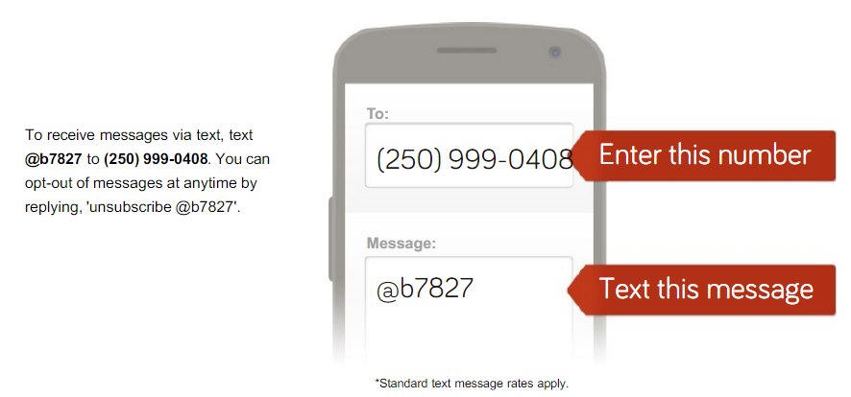
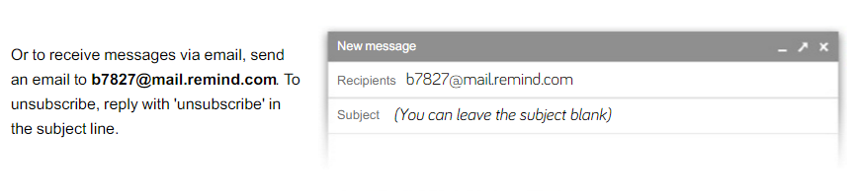

Students,

Please share this outline with your Parent/Guardian. Detach this last page, have your parent/guardian sign it, and return it back to me by Friday February 5th, 2016.

Parent /Guardian Information:

I am looking forward to working with your child in Social Studies 10 this semester. Please sign below to indicate that you have read the course outline. Please also include your preferred method of contact (e-mail or phone number).

Additionally, I have a class website that I regularly update with homework and resources pertaining to assignments and our course content. It can be found at: www.missbecksclass.weebly.com

If you would like to stay updated with what is going on in class, you can also sign up for “Remind” (details attached).

I look forward to working with you to provide the best possible learning experience for your child.

Student Name: __________________________________________________
Parent/Guardian Name: __________________________________________________
Email and/or phone: __________________________________________________
Parent/Guardian Signature: __________________________________________________

Any other important information that you would like me to know:

If you have any questions or concerns at all, please do not hesitate to contact me by email at jbeck@sd91.bc.ca or 250-692-7733.
I hope that your son/daughter enjoys the course!

Cheers,

Janice Beck

