Social Studies 10
Name:
Colonization: Residential Schools

Individual Survivor Historiography Assignment

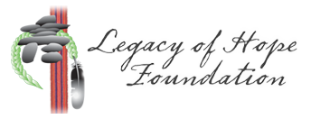
Instructions
PART ONE: Video + Notes
Visit http://wherearethechildren.ca/en/stories/. Select a survivor story to watch and listen to. Watch the video, and on a separate piece of paper take notes using a note-taking strategy of your choice.
*Make sure you write down at least three direct quotations from your survivor

PART TWO: Summary + Response
After viewing the video, answer the following questions in complete sentences.
- What were some things that stood out to you (surprised you, interested you, impacted you)?
- What was the residential school experience like for this person?
- What impact did this person’s experience at residential school have on the rest of their life?
- Oral history is the study of historical information by interviewing people who participated in or observed the events.
  - What are some of the advantages of using oral history to learn about the past?
  - What are some of the disadvantages of using oral history to learn about the past?
- Personal Response (your thoughts, feelings, opinion, etc.)

PART THREE: Sharing Circle
Each of you will introduce your survivor to the class. Please touch on the following:
- Short biography (age, gender, location, school they attended, etc.)
- What their experience at residential school was like
- What impact this experience had on the rest of their life
- Two powerful quotations from the survivor
As a listener, you will be required to complete the Sharing Circle Summary Sheet.

