Social Studies 10 Name: ____________________
Creating your ePortfolio on Weebly

Log In & Create Site
- Type in the address bar of your browser (internet explorer/chrome): students.weebly.com
- Type your username and password in, and click “Log in.”
- I have access to your usernames and passwords through my Weebly account, so if you lose yours or forget it, just ask me!
- Click on the orange button that says “Create a Site”
- Type in the title of your new site (e.g. (your name)’s ePortfolio)

Create Pages
- On the blue bar along the top, click on “Pages”

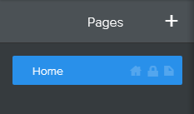
- On the left hand side, beside “Pages” click the “+” to add a new page
- Select “Standard Page”
- Title this page “Collective Identity”
- Click “Save”
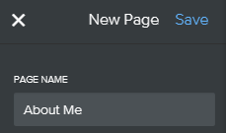
- Complete the same process to add pages with the following titles:
  - Social Responsibility
  - Confederation
  - Geography
  - Disparities in Power
  - Development of BC
Building Your Pages
- On the blue bar along the top, click on “Build”

You can build your pages by dragging items from the left (e.g. “Title” or “Text” to your pages.
- Add a “Title” to your page by dragging it over, and typing “Canadian Identity”
- Next, drag “Text” over, and add in the learning outcomes that you have demonstrated by completing the Canadian Stereotypes/Identity Project.

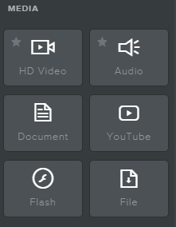
- Next, you will want to add your actual project here as a piece of evidence. To do this, scroll down on the left until you find “Document” under the Media heading.
- Drag “Document” over to your page. Click to upload your PowerPoint or word document.
- You should also add it as a downloadable file. Find “File” and drag it over to your page.
- Click on it to upload your PowerPoint/document, and for the file name, write “Canadian Stereotype Project”

