Social Studies 11 Name: ___________________________
What is History?
- History is essentially the ____________________________________________________ – how they lived, what they valued and how their lives were influenced by the time and place in which they were born.

- The study of history helps us to better understand _________________________________________________, as we can investigate the ________________________________________________ of specific historical events.

- Historians need to work as ______________________________________- piecing together the clues to be able to come to some conclusions about what life was like in the past.

Activity 1:
Use the pictures as clues to suggest what may have been considered important in these societies.

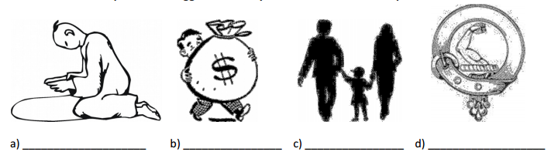

Time in History

- The term __________________ is often used to describe a particular period of history – for example “the medieval era”
- The term __________________ (abbreviated to c.) is used when an exact date is not known.

Activity 2:
Match each of these items to the approximate year of its release (choose from the dates in the box).
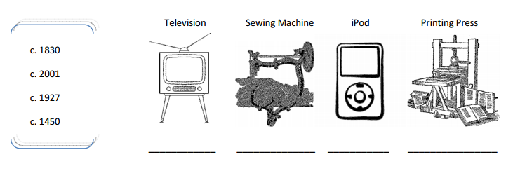

- Chronological order is: ______________________________________________________________________________________________________________________________________________________________________________________

List the inventions from Activity 2 in chronological order:

_________________________________________________________________________________________________

Sources and Evidence

- Historians learn about the past through examining ________________________________________. They can then use this evidence to construct a ______________________________________________ which can be used to investigate and explain the behaviour of people in the past.
- Evidence can be ______________________________________ (written – such as letters, diary entries, symbols) or ______________________________________ (not written – artifacts such as vases, buildings, photographs).

Activity 3:
Identify each of these historical sources as either literary or non-literary.
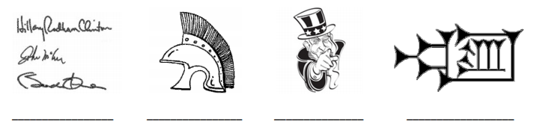

Historical evidence is also classified as either ___________________________ or ________________________________

Primary Sources: ____________________________________________________________________________________________________________________________________________________________________________________________________

Secondary Sources:
____________________________________________________________________________________________________________________________________________________________________________________________________

Activity 4:
In the spaces provided, sketch and explain an example of both a primary and a secondary source.

Activity 5:
Step 1: Write a list of ten items that a historian from the future could use to find out about what life was like for Canadian teenagers in 2015 (think about clothing, food, schooling, recreation… use your imagination!).
Step 2: Then, write 2-3 sentences which explain how two or more items from your list could be used by the historian to explain their arguments.

Fact vs. Opinion
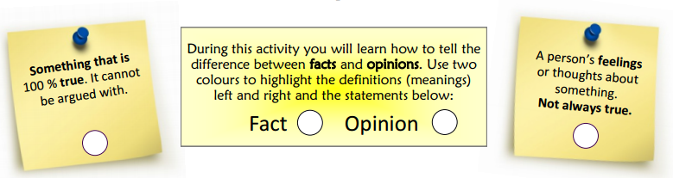
Twelve divided by two is six.
The Vancouver Canucks are the best hockey team in the world!
The L.A. Kings won the Stanley Cup in 2014.
The iPhone is better than all other smart phones.
A cockroach can live without its head for up to 9 days.
A fully grown giraffe is taller than a fully grown elephant
Dogs are better than cats because they are more playful.
Ottawa is the capital of Canada.
Napoleon was one of the greatest military leaders in world history.
Canada is the greatest country in the world.
Wolves are clever animals.
WWII was the most devastating war in history.
Pierre Trudeau was an amazing Prime Minister.

