Social Studies 11 Name: ____________________
The Lead-up to World War II
Video: https://www.youtube.com/watch?v=Q1JGtsilzwg
After WWI, Germany had become a ________________________________, but it was seen as ineffective.
Street battles erupted between extreme ______________________________ and __________________________ trying to start a revolution.
Adolf Hitler
- Seized control of the National Socialist Party, also known as the __________________________
- Attempted to _________________________ the government, but was unsuccessful and spent 9 months in prison, where he wrote a book called Mein Kampf.
- Blamed Germany’s problems on ___________________________.
- The ____________________________ of 1929 gave Hitler an opportunity, as he and his party seemed to offer solutions to __________________________ and _________________________.
- Hitler’s “security forces” were called: __________________________________
- In the 1932 election, the Nazi party became the __________________________ party in the German Pariament (Reichstag), and Hitler became Chancellor in ______________________.
- When the parliament burnt down, he blamed the ______________________________, declared ________________________ powers, and then used these powers to _____________all other political parties.
- When the president died, he declared himself president/Fuhrer of Germany. In his first years as Fuhrer, he spent millions on ________________________________ and also on a ________________________ program.
Threats to Peace
- The first threats to world peace came from _________________, which was already a ___________________________.
- Japan faced a growing population, and not enough _______________________________ to fuel its industries, so it looked to ______________________________ for resources.
- In 1931, the Japanese forces overran ______________________, and then turned to conquer ______________________, which it invaded and overran in 1937.
- In 1936, Japan signed a pact with ________________________________.
- The Western powers refused to _____________________ and the ___________________________ could do nothing.
Fascism in Italy
- __________________________ became the fascist dictator of Italy. He and his followers marched on ____________ and formed the government, consolidating all power in his hands.
- He, like Hitler, began massive ________________________ programs, gave people ______________, and built up the ____________________________________________________________.
- People began to see the fascist system as ____________________, compared to the _________________ systems of democracy.
- Italy threatened the country of ___________________________ (Ethiopia today), but the __________________ could do nothing. It was overrun by Italy within 6 months.
Civil War in Spain

VS.

- _________________ and ________________ sent tanks, aircraft, and troops to Spain to help Franco and the nationalists. Britain and France did not want to intervene.
- ____________, of Russia, sent help to the republicans in Spain, but they ended up surrendering to ___________.

Hitler’s Next Moves
- Seeing that ______________________ and _____________________ were not doing anything to stop aggression, Hitler started to pursue his aggressive policies.
- His ultimate goal was to expand Germany in to the ______________________.
- He built up the __________________ and introduced ______________________.
- The country of ________________ ended up being absorbed in to Germany.
- Hitler turned to the Sudetenland in Czechoslovakia. ____________________ and _____________________ signed an agreement to give this land to Germany, and Hitler agreed to not pursue any other lands.
- BUT, he now turned to _____________________ and the port of Dantzig. Britain and France said that they would ____________________________________ if he attacked Poland. Hitler did not care, because he thought that they would be weak opponents. His only worry was ____________________ on the eastern front.
- _______________ and Hitler signed a non-agression pact, which eliminated the risk of fighting Russia.
- Hitler ordered his armed forces to prepare for an attack on _______________________.

Definitions
Communism: the belief that all property is owned by the public (the people) rather than by individuals. People who believe in this political theory are considered “left wing” and are called communists.

Democracy: a system of government where the people vote to elect people who represent them.

Fascism: a government led by a dictator that has complete power over everything, and often emphasizes nationalism and racism. People who believe in this political theory are considered “right wing” and are called fascists.

Nationalism: patriotic feelings (being proud of one’s country): can become extreme where you feel like you are better than other countries.

Public works: the work of building things like roads, schools, etc. that is carried out by the government for the community or country.

Dictators:
Benito Mussolini (Italy) Adolf Hitler (Germany) Francisco Franco (Spain) Josef Stalin (Russia)
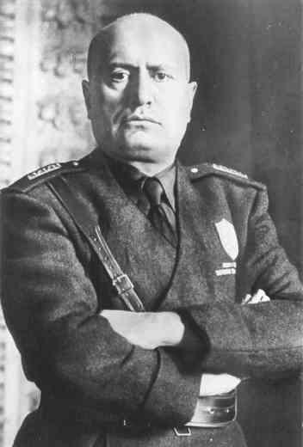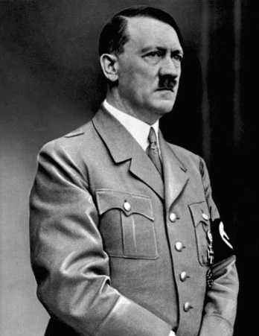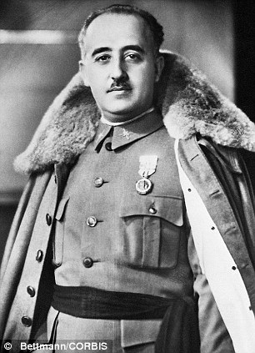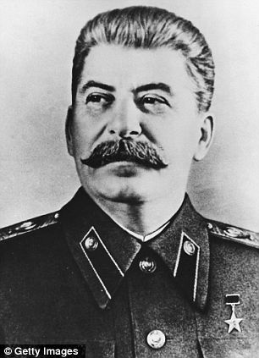
Word Bank
Intro | Communists | Democracy | Fascists
Adolf Hitler: | 1933 | Ban | Communists | Depression | emergency | Jews | Largest
 | Overthrow | Rearmament | Public works | SA Stormtroopers | Unemployment | Stock market crash | Nazis
Threats to Peace | China | Manchuria | Japan | Military power | Resources | Chinese Manchuria | Intervene
 | Nazi Germany |  | League of Nations
Italy | Rome | Jobs | Abyssinia | Weak | Strong | League of Nations | Mussolini
 | Public works |  | Army, navy & air force
Spain | Republicans (left, communist) |  | Nationalists (Franco, right, fascist) |  | Stalin | Hitler Mussolini | Franco
Hitler Moves | Austria | Britain (x2) | France (x2) | Poland (x2) | Russia | Conscription | East
 | Army | Declare war | Stalin

